Home Assignment III

Problem I: Edge Detection OpenCV

1.Canny : muti-stage algorithm to detect a wide range of edges in images.

-optimized auto thresholding edge detector that an image and based on local values,

-Technique to extract useful structural information from different vision objects and dramatically reduce the amount of data to be processes.

-Smooth image with Gaussian

-optimizes the trade-off between noise filtering and edge localization

-detect edges by double thresholding

-Thin edge by applying non-maxima suppression to the gradient magnitude

2. prewitt :an operator use within the edge detection algorithm, it is a discrete differentiation operator, computing an approximation of the gradient of the image intensity function.

-At each point in the image, the result of the prewitt operator is either the corresponding gradient vector or the norm of this vector.

-convolving the image with a small, separable, and integer values filter in horizontal and vertical direction.

-the gradient approximation which it produces is relatively crude, in particular for high frequency variations in the image.

3.Sober: create an image emphasizing edges.

-discrete differentiation operator

-at each point in the image, the result either r the corresponding gradient vector or the norm of this vector.

-convolving the in image with a small, separable, and integer-valued filter in the horizontal and vertical directions-relatively inexpensive in terms of computations.

4.Laplace: a differential operator given by divergence of the gradient of a function on Euclidean space.

Canny edge detection

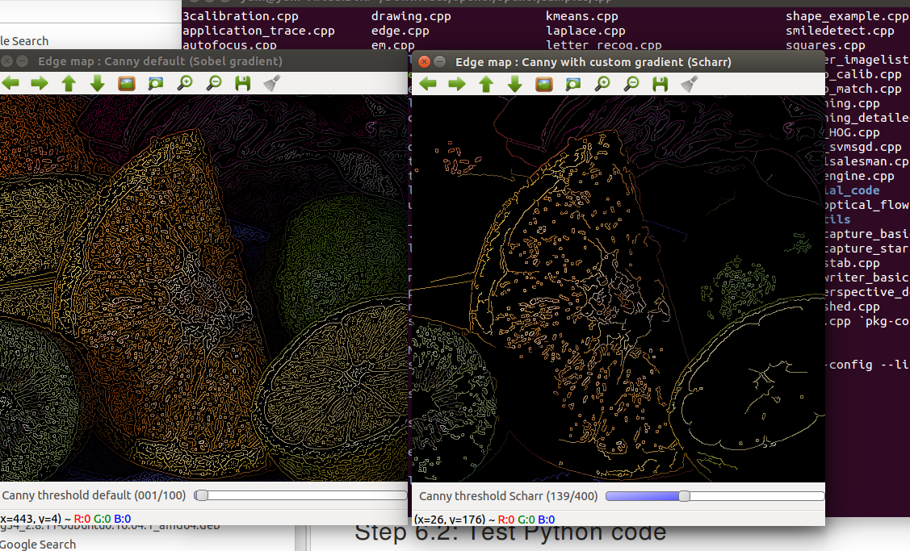

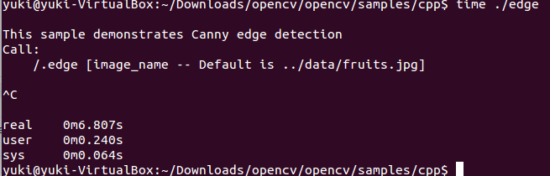

Quality result

